

Practices for Secure Software Report

Table of Contents
Document Revision History 3
Client 3
Instructions 3
Developer 4
1. Algorithm Cipher 4
2. Certificate Generation 4
3. Deploy Cipher 4
4. Secure Communications 4
5. Secondary Testing 4
6. Functional Testing 4
7. Summary 4
8. Industry Standard Best Practices 4

Document Revision History

Version | Date | Author | Comments
1.0 | 10/10/2026 | Kenneth Nimmo | Completed the algorithm cipher section
2.0 | 10/12/2026 | Kenneth Nimmo | Added the screenshots and written summary
3.0 | 10/14/2026 | Kenneth Nimmo | Added the industry best practices section

Client



Instructions

Submit this completed practices for secure software report. Replace the bracketed text with the relevant information. You must document your process for writing secure communications and refactoring code that complies with software security testing protocols.

- Respond to the steps outlined below and include your findings.
- Respond using your own words. You may also choose to include images or supporting materials. If you include them, make certain to insert them in all the relevant locations in the document.
- Refer to the Project Two Guidelines and Rubric for more detailed instructions about each section of the template.

Developer
Kenneth Nimmo

Algorithm Cipher

For the checksum, I chose to use SHA-256, which is a part of the SHA-2 family of cryptographic hash functions. It takes the input data and produces a digest that can be compared with a trusted expected value. This helps identify a change in the data, whether it was caused by an accidental error or an unauthorized modification.

For encryption, I would recommend AES-265 in GCM, where the application needs to protect stored financial data. IAS uses 128-bit blocks and supports keys of 128, 192, and 256 bits. GCM adds additional authentication so the application can detect changes to the encrypted data. For the HTTPS connection, the browser and server negotiate a TLS cipher suite; the SHA-256 setting in the controller does not choose that suite.

Random numbers are needed when generation secret keys and establishing secure connections. These values should come from a cryptographically secure generator, such as java’s SecureRandom, rather than a predictable source. AES-GCM also requires a nonce that must not be reused with the same key. The checksum itself does not need random input, since the same file or string must produce the same digest each time it is checked.

Encryption standards have changed as computing power and attack have improved over time. AES was selected from the Rijndael family in 2000, standardized in 2001, and updated editorially in 2023 without changing the algorithm. Hash standards have also changed, with NIST deprecating SHA-1 and providing SHA-2 and SHA-3 as approved options. I think SHA-256 is appropriate for this project because it is standardized and available through Java’s existing cryptography API, which allows the checksum to be added without introducing another runtime library

Certificate Generation
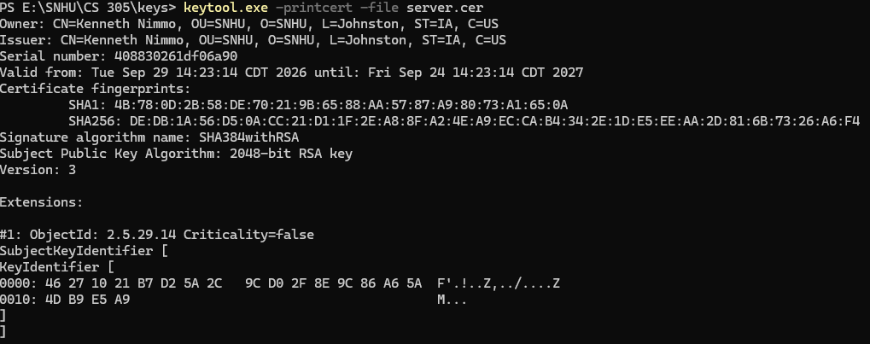

Deploy Cipher
Insert a screenshot below of the checksum verification.

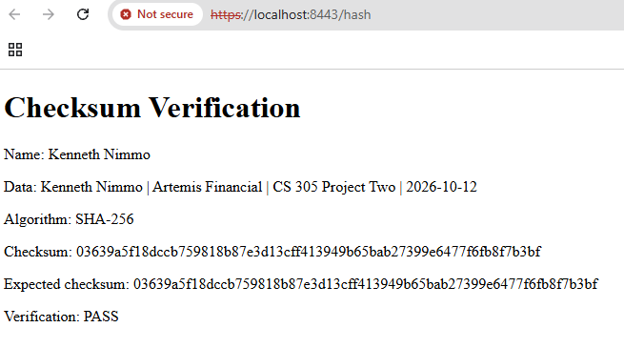

Secure Communications
Insert a screenshot below of the web browser that shows a secure webpage.

[Insert screenshots here.]

Secondary Testing
Insert screenshots below of the refactored code executed without errors and the dependency-check report.

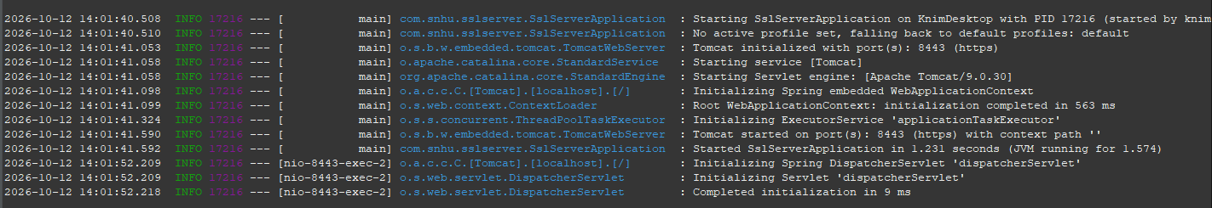
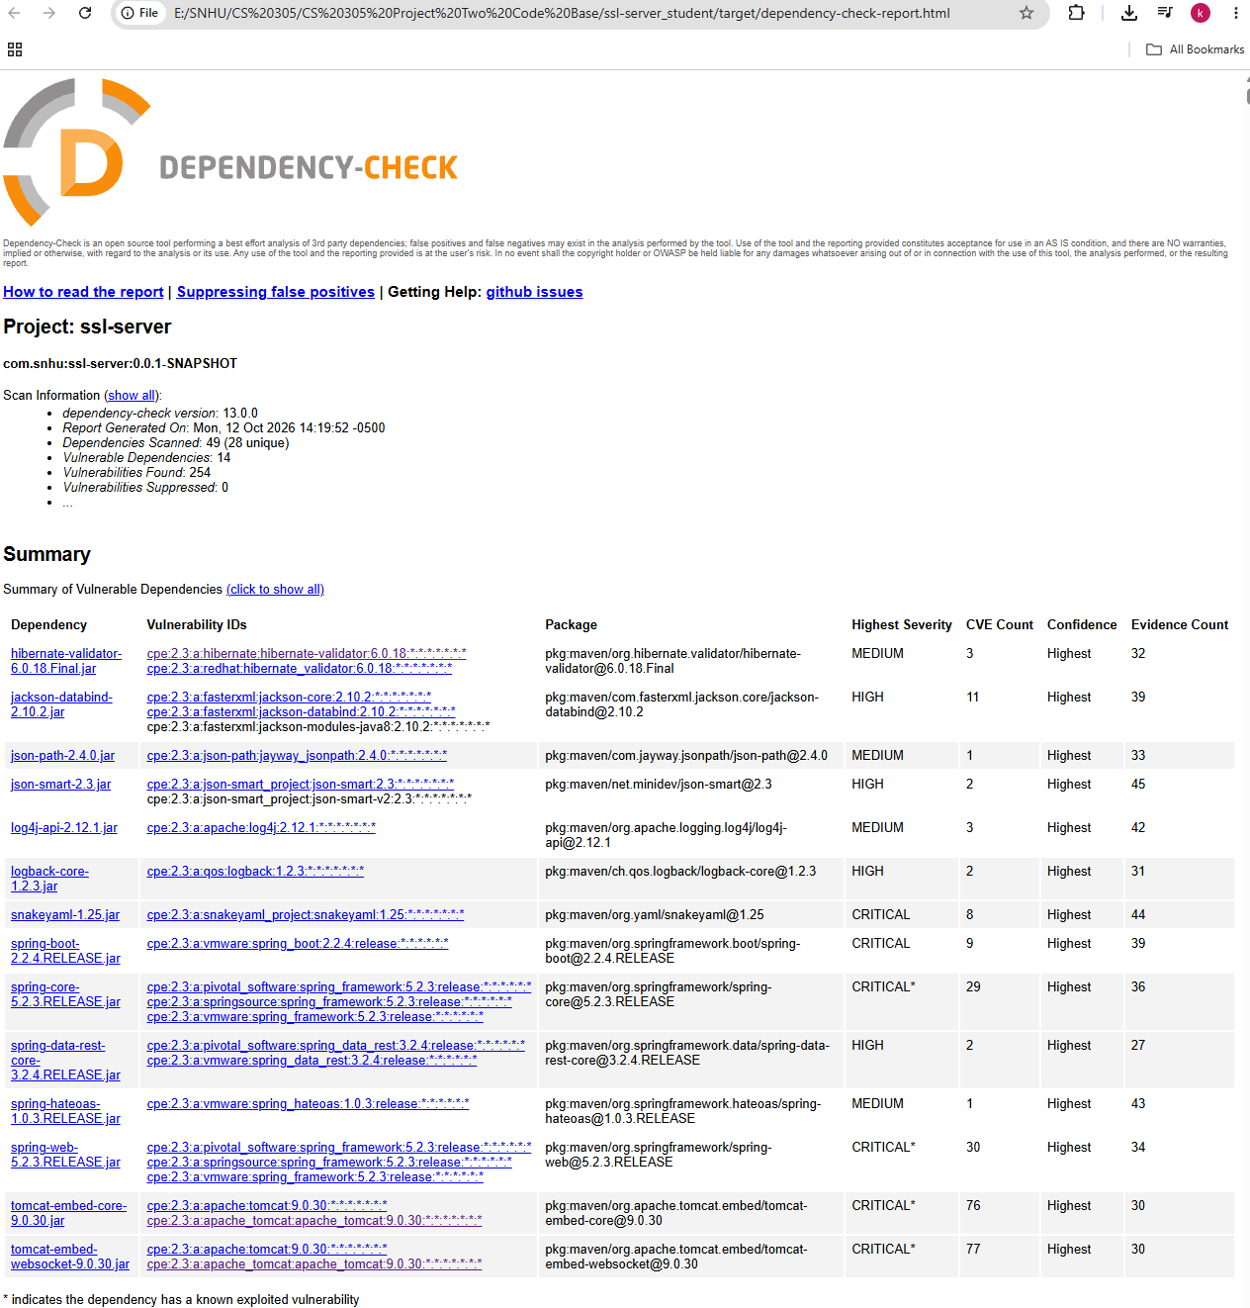

Functional Testing
Insert a screenshot below of the refactored code executed without errors.

Summary

For Artemis Financial, the architecture review focuses on the Spring Boot application, its /hash controller, the browser connection, and the libraries identified in the Maven configuration. This helps connect the security changes to the parts of the application that handle and display the data.

The main areas addressed in the refactoring art Cryptography and Client/Server. The SHA-256 implementation supports the Cryptography area by generating a complete checksum and comparing it with an independently calculated expected value. The HTTPS configuration and certificate procedures address the Client/Server area by protecting the connection and supporting server authentication when the certificate is trusted correctly. These controls add separate layers of security, since the checksum helps detect changed data while TLS protects the information during transmission. The fixed-data example still needs to be extended to hash actual file bytes before it can verify customer file transfers.

The diagram’s APIs, Code Error, Code Quality, and Encapsulation areas also relate to the changes. I limited the /hash API endpoint to GET, kept the hashing and hexadecimal conversion in separate methods, and created a new MessageDigest for each request. These choices make the behavior easier to review and avoid sharing any mutable digest state between requests. The error configuration keeps stack traces out of browser responses, while private constants keep the demonstration values within the controller and environment settings keep credentials out of the submitted configuration. Input Validation becomes more significant when the application accepts customer data or uploaded files, since those additions will require validation, file-size limits, and safe output handling.

Industry Standard Best Practices

I used Java’s established MessageDigest implementation rather than writing a custom hashing algorithm. I kept the input encoding explicit, preserved the complete hexadecimal digest, and added a separate expected-value comparison. I also kept the main application entry point and existing dependency declarations while limiting the changes to the checksum demonstration, communication settings, and credential configuration. These choices were made in order to help maintain the application’s behavior while making the security changes easier to implement and review.

The production requirements go further than the local demonstration. They include a trusted certificate, supported software versions, protected private keys, authentication and authorization for customer information, and repeated security testing after changes. A successful dependency scan should also be considered alongside functional testing and manual review, since each checks a different part of the application.

For Artemis Financial, these practices help protect customers’ financial plans and reduce the chance of exposing or altering sensitive information. They also make it easier for the development team to understand the security controls, investigate a problem, and maintain the application over time. Overall, I think the value comes from making security part of the normal development process, with changes supported by evidence that can be reviewed and repeated.

